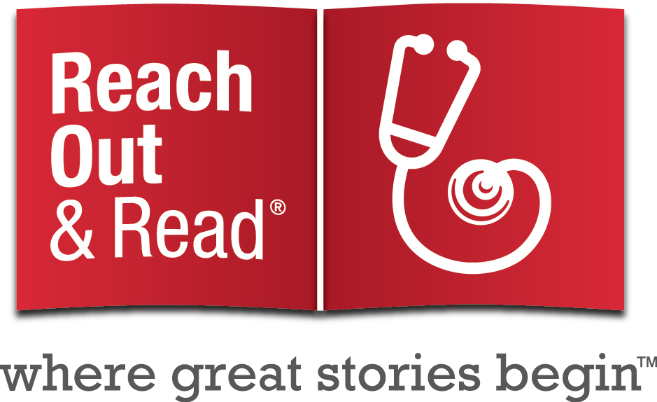
TALKING WITH PARENTS ABOUT BOOKS

The Reach Out and Read model depends upon the advice healthcare providers give to parents.* Using books in the exam room allows the medical provider to model book sharing directly and to comment on the child’s response to the book. Here are some suggestions for making literacy development part of your standard anticipatory guidance.

The first year
- Babies love your voice: sing, talk, and read aloud as often as possible.
- As you observe the baby looking at pictures: She’s really looking, moving her arms with excitement, and talking. Babies love picture books and books with rhymes.
- You’re teaching your baby that sitting on your lap and being read to feels good and that books are enjoyable.
- It’s okay if your child eats the book! This is how babies explore and learn about their world.

12 to 18 months
- If you ask, What’s that? and then name the picture, your baby will learn the names for things.
- Once babies start to walk, holding them on your lap can be a struggle. Some children will want to move around during a story. That’s OK.
- Read stories every day, but let your child be in charge of how long you read.
- When your child grabs the book, she is showing a healthy drive for independence. She’s not being bad.

18 to 36 months
- Stories are a good way to help toddlers increase their attention spans. If your toddler listens to a story for five minutes, that’s a long time. As children grow, they will sit longer.
- Sometimes you don’t have to read what’s actually written on the page. You can just talk about the pictures, or make up a story about what’s happening.
- Children learn by imitating. Does she ever read to her teddy bears or dolls? Does she see you read?
- One way children learn to read – and learn new words – is by hearing the same story again and again. It might be boring to you, but it isn’t to him. Toddlers enjoy the repetition.

3 years and up
- Talk about the pictures, and the story. Ask who, what and where questions. But remember to give your child time to answer.
- Your child might want to tell you a story. Every time she retells a favorite story, or changes the story, she is practicing using language in a very important way.
- Scribbling and pretend writing is the first step toward real writing. Does he ever pretend to write? Do you ever show him the letters in his name?
- Do you have a library card yet? Going to the library regularly opens up the world inside books. Notice your preschooler’s interests and let her choose which books to take home.

Reading aloud and talking together every day
helps create secure relationships and a strong foundation for learning.
Books can become an important part of every family’s naptime, playtime, and bedtime routines.

*Our Leyendo Juntos initiative provides special materials/training for providers who serve Latino families. Click here.

